INT- 374 DATA ANALYTICS WITH POWER BI
PROJECT REPORT
(Project Semester Aug-Jan 2025)
TG NPDCL Commercial Energy Consumption Dashboard – October 2025
Submitted by:
Name of student: Ponnuru Nithin
Registration No: 12303486
Programme and Section: K23MS
Course Code: INT-374
Submitted by:
Name of faculty: Savleen Kaur
U.Id: 18306


School of Computer Science Engineering
Lovely Professional University, Phagwara

CERTIFICATE

This is to certify that Nithin Ponnuru bearing Registration no. 12303486 has completed INT – 374 project titled, TG – NPDCL Commercial Energy Consumption Dashboard – Oct 2025 my guidance and supervision. To the best of my knowledge, the present work is the result of his/her original development, effort and study.

Name of the Supervisor: Salveen Kaur
Signature: Salveen Kaur
Designation of the Supervisor:
School of Computer Science Engineering
Lovely Professional University
Phagwara, Punjab.

Date: 18-12-2025

DECLARATION

I, Nithin Ponnuru, student of under School of Computer Science Engineering CSE/IT Discipline at, Lovely Professional University, Punjab, hereby declare that all the information furnished in this project report is based on my own intensive work and is genuine.

Name of the student: Nithin Ponnuru
Registration No: 12303486
Date: 18-12-2025
Signature: P. Nithin

Acknowledgement:
I take this opportunity to express my sincere gratitude to all those who contributed directly and indirectly to the successful completion of this project titled “TG NPDCL Commercial Electricity Consumption & Billing Analysis – October 2025,” developed using Power BI as part of my academic curriculum.
First and foremost, I would like to express my heartfelt thanks to my project guide and faculty mentor, Ms. Salveen Kaur, for her continuous guidance, encouragement, and valuable support throughout the project. Her insightful suggestions, constructive feedback, and patient mentoring played a crucial role in shaping the direction and quality of this work. Her guidance helped me understand the practical application of data analytics concepts and strengthened my analytical and visualization skills.
I would also like to extend my gratitude to all the faculty members of my department for providing a strong academic foundation in data science and business intelligence tools. The knowledge gained through coursework and practical sessions was instrumental in successfully implementing data modeling, DAX calculations, and interactive dashboard design using Power BI.
I sincerely thank the Government of Telangana for providing access to reliable and authentic data through the Telangana Open Data Portal (data.telangana.gov.in). Working with government-provided open data from TG NPDCL allowed me to analyze real-world electricity consumption and billing scenarios, enhancing my understanding of data-driven decision-making and public sector analytics.
I am thankful to Microsoft Power BI for providing a powerful platform that enabled effective data visualization and analysis. The tool’s features helped transform raw data into meaningful insights through KPIs, charts, slicers, and map-based visualizations.
I would also like to acknowledge my institution for providing the necessary infrastructure, learning environment, and academic support required to complete this project successfully. I extend my appreciation to my classmates and peers for their cooperation, valuable discussions, and constructive feedback during the project development.
Finally, I am deeply grateful to my family for their constant encouragement, motivation, and support throughout my academic journey. Their belief in me played a vital role in completing this project with dedication and confidence.
Table of Content:

1. Introduction
2. Scope of the Analysis
3. Existing System
- Drawbacks or limitations of existing system
4. Source of dataset
5. Data Preprocessing/ Cleaning
6. Data Modelling ( optional)
7. Analysis on dataset (for each analysis)
- Introduction
- General Description
- Specific Requirements, functions and formulas
- Analysis results
- Visualization
8. List of Analysis with results
9. Future scope
10. References

INTRODUCTION:

In today’s digital era, data plays a crucial role in decision-making across various industries. The power distribution sector generates massive volumes of data related to electricity consumption, billing, service connections, and load management. Analyzing such data effectively helps organizations improve operational efficiency, ensure better resource allocation, and enhance customer satisfaction. Business Intelligence (BI) tools like Power BI enable users to transform raw datasets into meaningful insights through interactive dashboards and visual analytics.
This project titled “TG NPDCL Commercial Electricity Consumption & Billing Analysis – October 2025” focuses on analyzing commercial electricity consumption data provided by the Telangana Northern Power Distribution Company Limited (TG NPDCL). The dataset is sourced from the Telangana Open Data Portal (data.telangana.gov.in), a government initiative to promote transparency and open access to public data. Using this dataset, the project aims to analyze electricity usage patterns, billing efficiency, connected load distribution, and geographical consumption trends across different administrative levels.
The primary objective of this project is to design an interactive Power BI dashboard that provides clear insights into commercial electricity consumption and billing performance. By using KPIs, charts, slicers, and map visuals, the dashboard allows stakeholders to explore the data dynamically and identify high-consumption areas, billing gaps, and operational inefficiencies. This project also demonstrates the application of data preprocessing, data modeling, and visualization techniques in solving real-world problems.
From an academic perspective, this project helps in understanding how data science concepts are applied in practical scenarios. It enhances skills related to data cleaning, DAX calculations, dashboard design, and analytical thinking. Additionally, working with a government-provided dataset improves awareness of public sector analytics and the importance of data-driven governance.
Overall, this project serves as a comprehensive example of how Power BI can be used to analyze large-scale electricity data and convert it into actionable insights for planning, monitoring, and decision-making purposes.

PROBLEM STATEMENT:
Electricity distribution organizations generate large volumes of operational data related to energy consumption, service connections, billing status, and connected load across different administrative regions. In the case of TG NPDCL, commercial electricity consumption and billing data are available in raw, tabular formats through government data portals. However, this data is not readily interpretable for effective decision-making without proper analysis and visualization.
The existing system primarily relies on static reports and spreadsheets, which makes it difficult to identify key patterns such as high-consumption areas, billing inefficiencies, unbilled services, and regional demand variations. The lack of interactive and visual analytical tools limits the ability of stakeholders to quickly assess performance, compare regions, and take timely corrective actions. Moreover, manual analysis of large datasets is time-consuming, prone to errors, and does not support dynamic exploration of data.
There is a need for an efficient analytical solution that can transform raw electricity consumption and billing data into meaningful insights using modern business intelligence techniques. Such a solution should provide clear Key Performance Indicators (KPIs), region-wise comparisons, hierarchical analysis, and geographical visualization to support informed decision-making.
Therefore, the problem addressed in this project is to design and develop an interactive Power BI dashboard that analyzes commercial electricity consumption and billing performance of TG NPDCL using government-provided open data. The dashboard aims to enable stakeholders to easily explore the data, identify operational inefficiencies, understand consumption distribution, and support data-driven planning and management in the electricity distribution sector.

SCOPE OF THE ANALYSIS:
The scope of this analysis is limited to commercial electricity consumption data under TG NPDCL for the month of October 2025. The dataset includes information related to administrative divisions such as Circle, Division, Sub-Division, Section, and Area, along with attributes like total services, billed services, connected load, and electricity units consumed.
The analysis focuses on understanding consumption patterns across different regions and identifying operational insights related to billing efficiency and service coverage. It does not include residential or industrial categories, nor does it analyze long-term trends across multiple months or years. The absence of time-series data restricts trend analysis over time; however, comparative analysis across regions provides valuable insights.
Within this scope, the project covers:
- Identification of high connected load areas
- Comparison of billed and unbilled services
- Hierarchical consumption analysis (Circle → Area)
- Consumption density analysis using services and load
- Geographical visualization of electricity usage using maps
The analysis is intended to support operational planning, billing performance monitoring, and regional demand assessment. It can be useful for electricity distribution authorities, analysts, and policymakers to identify high-demand zones and areas requiring infrastructure improvement.
The scope is further limited by the accuracy and completeness of the dataset. Since the data is collected and published by a government body, it is assumed to be reliable, but minor inconsistencies may still exist. The analysis does not include predictive modeling or forecasting, as the primary focus is descriptive and diagnostic analytics.

EXISTING SYSTEM:
Traditionally, electricity consumption and billing data are managed through manual reports, spreadsheets, and static summaries. These systems often rely on tabular data representations that make it difficult to extract meaningful insights quickly. Decision-makers must manually interpret large datasets, which increases the chances of errors and delays.
In many cases, existing systems provide limited visualization capabilities and lack interactivity. Reports are usually generated periodically and do not allow dynamic filtering or drill-down analysis. As a result, identifying high-consumption areas, billing inefficiencies, or service gaps becomes time-consuming and inefficient.
i. Drawbacks or Limitations of Existing System
- Lack of interactive dashboards
- Time-consuming manual analysis
- Difficulty in identifying regional patterns
- No real-time or dynamic filtering
- Limited geographical visualization
- Higher chances of human error
- Poor decision-support capabilities
These limitations highlight the need for a modern BI-based analytical system.

SOURCE OF DATASET:
The dataset used in this project is sourced from the Telangana Open Data Portal (https://data.telangana.gov.in), an official government platform that provides public access to datasets published by various departments. The specific dataset relates to TG NPDCL commercial electricity consumption details for October 2025.
Using government-provided data ensures authenticity, transparency, and reliability. The dataset includes structured attributes such as service counts, billed services, load values, and electricity units consumed. This makes it suitable for analytical and visualization purposes.
The open data initiative encourages researchers, students, and analysts to use public data for innovation, analysis, and policy evaluation. This project demonstrates the effective utilization of such open government data for academic and analytical purposes.
DATASET DESCRIPTION:
The dataset used in this project is titled “TG NPDCL Commercial Electricity Consumption Details – October 2025” and is sourced from the Telangana Open Data Portal (data.telangana.gov.in), an official government platform that provides access to publicly available datasets. The data is published by Telangana Northern Power Distribution Company Limited (TG NPDCL) and represents authentic, government-verified information. It focuses exclusively on commercial electricity consumers and provides a detailed snapshot of electricity usage and billing performance for a single reporting period, October 2025. Since the data is collected and released by a government authority, it ensures reliability, transparency, and suitability for academic and analytical purposes.
The dataset contains structured information across multiple administrative levels, including Circle, Division, Sub-Division, Section, and Area, enabling region-wise and hierarchical analysis. In addition to geographical attributes, it includes key operational parameters such as total number of services, billed services, connected load (in kilowatts), and electricity units consumed (in kWh). This structure makes the dataset well suited for descriptive and comparative analysis using business intelligence tools like Power BI. Although the dataset does not support long-term trend analysis due to its single-month scope, it is highly effective for understanding regional consumption patterns, billing efficiency, load distribution, and service coverage within the TG NPDCL operational area.
Attribute Name | Description | Data Type
Circle | Represents the highest administrative region under TG NPDCL, usually corresponding to districts | Text
Division | Sub-level administrative unit under a Circle | Text
SubDivision | Operational unit under a Division | Text
Section | Smaller administrative area responsible for local electricity distribution | Text
Area | Specific locality or commercial area within a Section | Text
CatDesc | Category description of electricity consumers (Commercial) | Text
TotServices | Total number of electricity service connections in the area | Numeric
BilledServices | Number of services that have been billed during the period | Numeric
Load | Connected electrical load measured in kilowatts (kW) | Decimal
Units | Total electricity consumption measured in units (kWh) | Numeric
Month | Reporting period of the data (October 2025) | Text
Data Source | Telangana Open Data Portal (Government of Telangana) | Text

DATASET CHARACTERISTICS:
- Dataset Name: TG NPDCL Commercial Electricity Consumption Details
- Data Source: Telangana Open Data Portal (data.telangana.gov.in)
- Data Provider: Telangana Northern Power Distribution Company Limited (TG NPDCL)
- Type of Data: Structured, tabular data
- Nature of Data: Secondary data (government-provided open data)
- Category: Commercial electricity consumption and billing data
- Time Period Covered: October 2025
- Geographical Coverage: Telangana state (TG NPDCL operational regions)
- Level of Analysis: Circle, Division, Sub-Division, Section, and Area level
- Key Attributes Included:
  - Administrative region details
  - Total number of services
  - Number of billed services
  - Connected load (kW)
  - Electricity units consumed (kWh)
- Data Granularity: Area-level data aggregated at higher administrative levels
- Data Format: CSV (Comma-Separated Values)
- Data Quality: Reliable and authentic (government-verified)
- Missing Values: Minimal / negligible
- Data Preprocessing Required:
  - Data type verification
  - Creation of calculated measures (KPIs)
  - Minor cleaning and formatting
- Analytical Suitability:
  - Descriptive analysis
  - Comparative analysis
  - Geographical analysis
  - Business intelligence and dashboarding
- Limitations:
  - Single-month dataset (no time-series analysis)
  - Limited to commercial consumer category

DATA PREPROCESSING:
Data preprocessing is a crucial step in any data analysis project. The raw dataset was imported into Power BI and examined for inconsistencies, missing values, and incorrect data types. Column names were reviewed to ensure clarity and consistency.
The preprocessing steps included:
- Verifying data types (numeric, text)
- Handling missing or null values
- Removing duplicate records (if any)
- Ensuring consistent naming conventions
- Creating calculated measures using DAX
Proper preprocessing ensured that the data was clean, reliable, and ready for analysis. This step significantly improved the accuracy and clarity of the dashboard outputs.

DATA MODELLING:
Although the dataset consists of a single primary table, basic data modeling was applied using Power BI measures. DAX formulas were used to calculate KPIs such as Total Units, Billing Efficiency, Units per Service, and Billing Gap.
Logical relationships between fields were maintained, and measures were used instead of calculated columns wherever possible to improve performance. This lightweight data modeling approach was sufficient for descriptive analysis and interactive reporting.

EXPLORATORY DATA ANALYSIS (EDA):
Exploratory Data Analysis (EDA) is a crucial step in understanding the structure, patterns, and variations in the dataset before developing dashboards and deriving insights. The EDA process for the TG NPDCL Commercial Electricity Consumption Dataset (October 2025) was carried out using Power BI matrix visuals, table visuals, summary statistics, and interactive charts. These tools enabled efficient aggregation, grouping, and comparison of data across different administrative levels.

1. Univariate Analysis:
Electricity Units Consumption Distribution
- Observation: Electricity consumption values range from low-consumption commercial areas to very high-consumption zones.
- Power BI Tool Used: KPI cards and bar charts based on aggregated values.
- Insight: Electricity units are unevenly distributed, with a small number of areas accounting for a significant portion of total consumption.
Connected Load (kW) Distribution
- Observation: Connected load varies widely across regions.
- Power BI Tool Used: Summary statistics and KPI visuals.
- Insight: Certain areas operate under high connected load, indicating concentrated commercial activity.
Billing Efficiency Overview
- Observation: Billing efficiency remains high in most regions, while some areas show noticeable billing gaps.
- Power BI Tool Used: Calculated measures and KPI cards.
- Insight: Specific sections require improvement in billing coverage.

2. Categorical Analysis:
Electricity Consumption by Circle
- Aggregation Method: Power BI matrix visual with Circle as rows and Total Units as aggregated values.
- Visualization: Bar chart.
- Insight: A few circles contribute a major share of total electricity consumption.
Division-wise Consumption Analysis
- Aggregation Method: Matrix visual summarizing Total Units by Division.
- Visualization: Column chart.
- Insight: Electricity consumption varies significantly across divisions.
Section-wise Billing Performance
- Aggregation Method: Matrix visual with Section as rows and Billed vs Unbilled Services as values.
- Visualization: 100% stacked bar chart.
- Insight: Certain sections show higher proportions of unbilled services.

3. Hierarchical Analysis:
Circle → Area Consumption Breakdown
- Hierarchy Used: Circle and Area fields in a Power BI hierarchy.
- Visualization: Sunburst chart or Treemap.
- Insight: Electricity consumption is concentrated in specific areas within each circle.

4. Density and Relationship Analysis:
Units vs Services Relationship
- Analysis Method: Relationship analysis using aggregated measures.
- Visualization: Scatter chart with Area as detail.
- Insight: Some areas consume disproportionately high electricity relative to service count.
Impact of Connected Load
- Analysis Method: Comparative analysis of load and consumption.
- Visualization: Scatter chart with bubble size representing load.
- Insight: Connected load strongly influences electricity consumption.

5. Geographic Analysis:
District-wise Electricity Consumption
- Aggregation Method: Table and matrix visuals summarizing Total Units by Circle.
- Visualization: Filled Map.
- Insight: Certain districts exhibit significantly higher electricity demand.

6. Summary of EDA Findings:
- Electricity consumption is unevenly distributed across regions.
- High-load areas contribute disproportionately to total consumption.
- Billing efficiency varies across sections.
- Load intensity is a strong indicator of usage.
- Geographical analysis reveals high-demand districts.

ANALYSIS ON DATASET:

OVERALL ANALYSIS:
i. Introduction:
The overall analysis provides a comprehensive view of commercial electricity consumption and billing performance under TG NPDCL. This analysis acts as a foundation for detailed objective-wise analysis by summarizing key performance indicators and regional consumption patterns.
ii. General Description:
The overall analysis focuses on total electricity units consumed, number of services, billed services, billing efficiency, connected load, and consumption distribution across circles and divisions. It allows users to understand the dataset at a high level and identify regions that require deeper investigation.
iii. Specific Requirements, Functions and Formulas:
Key DAX measures used include:
- Total Units = SUM(Units)
- Total Services = SUM(TotServices)
- Billed Services = SUM(BilledServices)
- Billing Efficiency % = (Billed Services / Total Services) × 100
- Average Load kW = AVERAGE(Load)
iv. Analysis Results:
The analysis reveals that electricity consumption is unevenly distributed across regions. Some circles and divisions account for a major share of total consumption. Billing efficiency is generally high, but certain areas show noticeable billing gaps.
v. Visualization:
KPI cards, bar charts, column charts, treemaps, pie charts, line charts, slicers, and tables were used to present an interactive and comprehensive overview of the dataset.

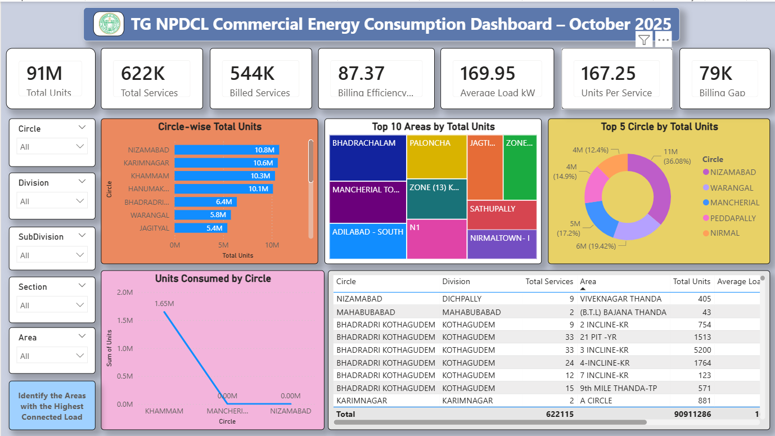
OBJECTIVE 1 – Identify Areas with the Highest Connected Load:
i. Introduction:
This objective focuses on identifying areas operating under high connected electrical load, which indicates heavy commercial activity and higher demand on infrastructure.
ii. General Description:
Connected load represents the maximum power demand capacity of an area. Analyzing connected load helps in understanding infrastructure stress and planning capacity upgrades.
iii. Specific Requirements, Functions and Formulas:
- Measure Used:
Average Load kW = AVERAGE(Load)
- Slicer: Circle
iv. Analysis Results:
The analysis highlights specific circles and areas with significantly higher connected load compared to others. These regions are likely to experience higher demand pressure and may require infrastructure strengthening.
v. Visualization:
A Gauge Chart was used to represent the average connected load dynamically, allowing quick identification of high-load zones.
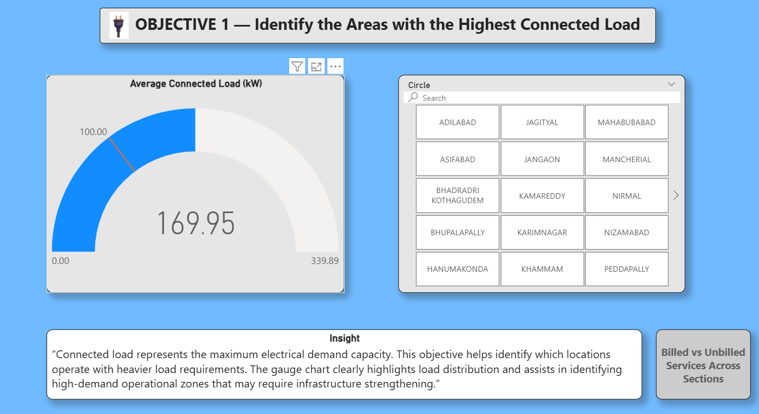
OBJECTIVE 2 – Compare Billed vs Unbilled Services Across Sections
i. Introduction:
This objective evaluates billing performance by comparing billed and unbilled services across different sections.
ii. General Description:
Billing efficiency is a critical operational metric. Comparing billed and unbilled services helps identify revenue leakage and operational inefficiencies.
iii. Specific Requirements, Functions and Formulas:
- Unbilled Services = Total Services – Billed Services
- Slicer: Division
iv. Analysis Results:
Most sections show high billing coverage; however, certain sections have a relatively higher proportion of unbilled services, indicating areas where billing processes can be improved.
v. Visualization:
A 100% Stacked Bar Chart was used to show the proportion of billed and unbilled services across sections.
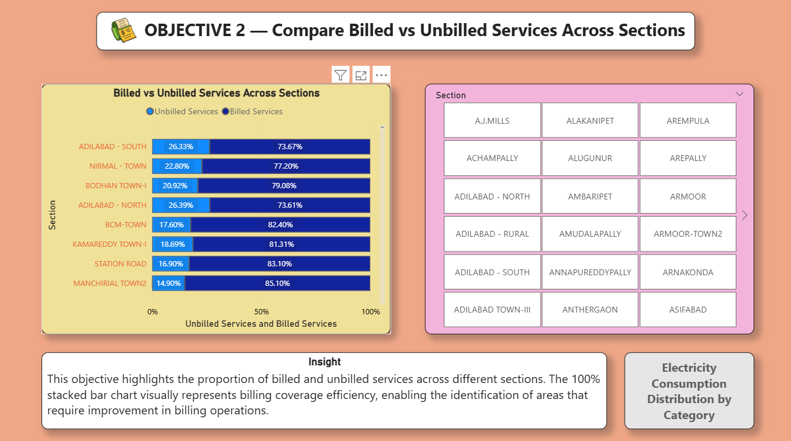
OBJECTIVE 3 – Analyze Hierarchical Consumption (Circle → Area)
i. Introduction:
This objective analyzes electricity consumption across hierarchical administrative levels.
ii. General Description:
Hierarchical analysis helps identify how electricity consumption is distributed from higher administrative units (circles) down to specific areas.
iii. Specific Requirements, Functions and Formulas:
- Measure Used: Total Units
- Hierarchy: Circle → Area
- Slicer: Circle
iv. Analysis Results:
The analysis shows that within each circle, consumption is concentrated in a limited number of areas rather than being evenly distributed.
v. Visualization:
A Sunburst Chart / Treemap was used to represent hierarchical consumption patterns clearly.
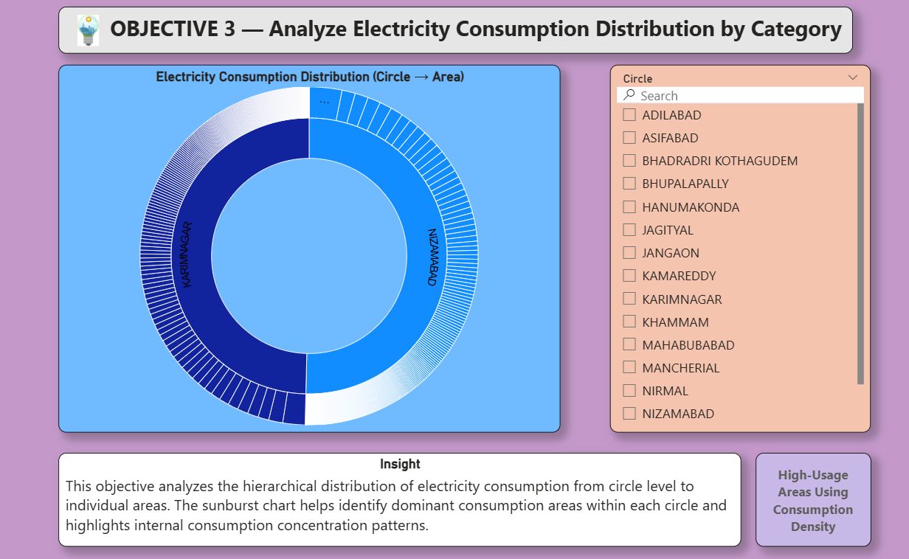
OBJECTIVE 4 – Identify High-Usage Areas Using Consumption Density
i. Introduction:
This objective identifies areas with unusually high electricity usage relative to service count and load.
ii. General Description:
Consumption density analysis helps detect areas where electricity usage is disproportionately high, indicating intensive commercial activity.
iii. Specific Requirements, Functions and Formulas:
- X-axis: Total Services
- Y-axis: Total Units
- Bubble Size: Load
- Slicer: Section
iv. Analysis Results:
Certain areas consume significantly higher electricity despite having fewer services, indicating high-usage commercial zones.
v. Visualization:
A Scatter Chart was used to visualize consumption density and identify outliers.
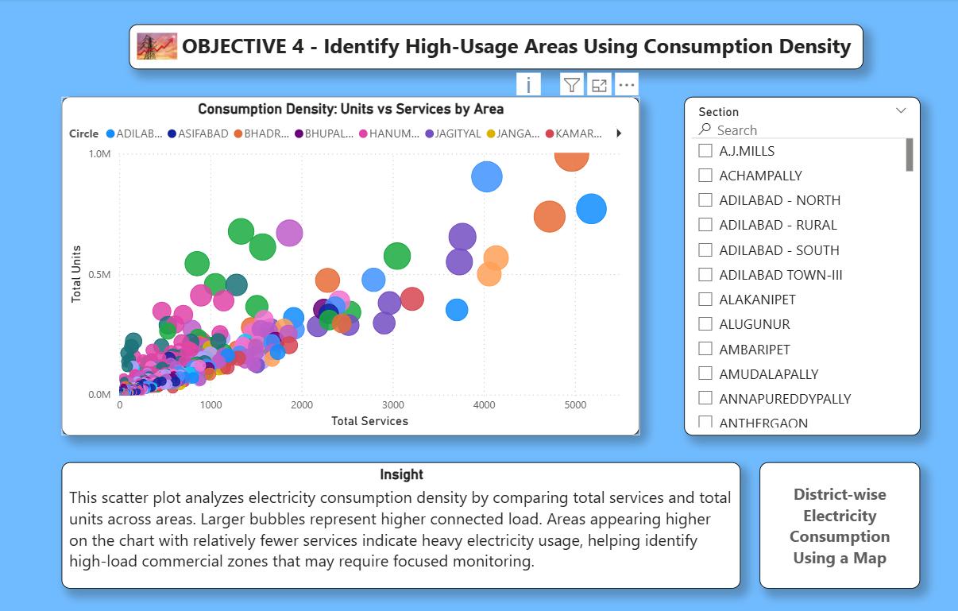
OBJECTIVE 5 – District-wise Electricity Consumption (Geographical Analysis)
i. Introduction:
This objective visualizes electricity consumption geographically to identify high-demand districts.
ii. General Description:
Geographical analysis helps understand spatial patterns in electricity demand and supports regional planning and resource allocation.
iii. Specific Requirements, Functions and Formulas:
- Location: Circle (District)
- Measure: Total Units
- Slicer: Division
iv. Analysis Results:
The analysis reveals that certain districts have significantly higher electricity consumption compared to others, highlighting demand concentration.
v. Visualization:
A Filled Map was used to represent district-wise electricity consumption using color intensity.
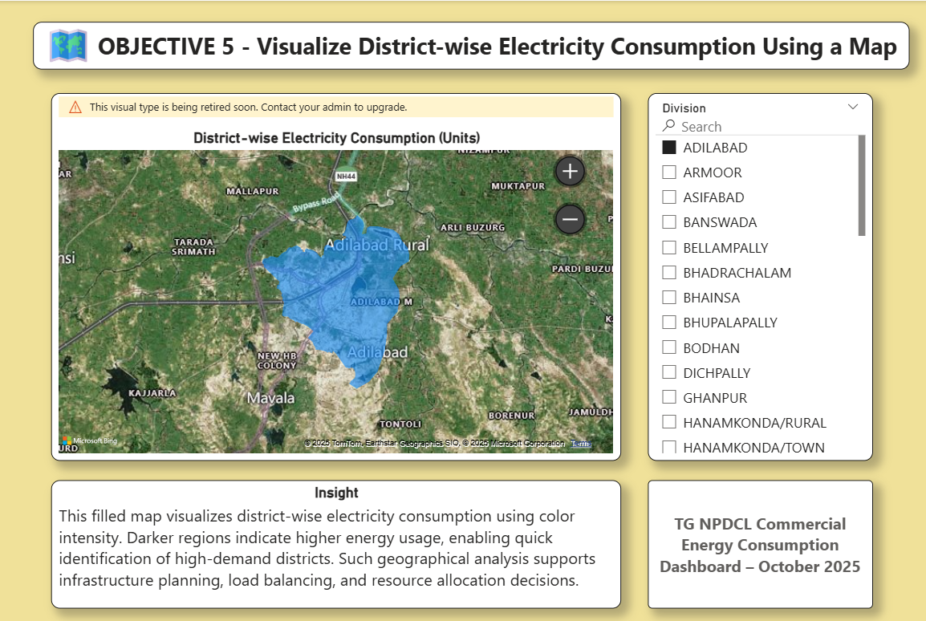
8. LIST OF ANALYSIS WITH RESULTS:
The following analyses were performed on the TG NPDCL commercial electricity consumption dataset using Power BI. Each analysis contributed to understanding different operational and consumption aspects of the electricity distribution system.
1. Overall Consumption and Billing Analysis
- Result: Electricity consumption is unevenly distributed across regions, with certain circles and divisions contributing a major share of total units consumed. Billing efficiency is generally high, but a few areas show noticeable billing gaps.
2. Connected Load Analysis
- Result: Some areas operate under significantly higher connected load, indicating intensive commercial activity and increased demand on electrical infrastructure. These areas may require capacity upgrades and load balancing.
3. Billed vs Unbilled Services Analysis
- Result: Most sections have a high proportion of billed services; however, certain sections exhibit higher unbilled service percentages, highlighting potential revenue leakage and the need for improved billing operations.
4. Hierarchical Consumption Analysis (Circle → Area)
- Result: Electricity consumption within each circle is concentrated in specific areas rather than being evenly distributed. This helps identify localized high-demand zones.
5. Consumption Density Analysis
- Result: Some areas consume disproportionately high electricity relative to the number of services, indicating high-usage commercial zones that may require focused monitoring.
6. Geographical (District-wise) Consumption Analysis
- Result: The map-based analysis reveals clear geographical patterns, with certain districts showing significantly higher electricity demand compared to others. This supports region-based planning and infrastructure development.
Overall, these analyses provided a comprehensive understanding of electricity consumption behavior, billing performance, and regional demand patterns under TG NPDCL.

9. FUTURE SCOPE:
The current project focuses on descriptive and diagnostic analysis using a single month of commercial electricity consumption data. There are several opportunities to extend and enhance this work in the future.
- Time-Series Analysis: Incorporating multi-month or multi-year data would enable trend analysis and seasonal pattern identification.
- Predictive Analytics: Machine learning models can be applied to forecast future electricity demand and billing performance.
- Real-Time Dashboards: Integration with live data sources can support real-time monitoring of consumption and billing.
- Category Expansion: Including residential and industrial consumer data would provide a holistic view of electricity usage.
- Advanced Analytics: Techniques such as anomaly detection can help identify unusual consumption or billing behavior.
- Policy Support: Insights from extended analysis can assist policymakers in infrastructure planning and demand management.
- Automation: Automated data refresh and alert systems can improve operational efficiency.
These enhancements would significantly increase the analytical depth and practical applicability of the dashboard.

10. REFERENCES:
- Telangana Open Data Portal – Government of Telangana
https://data.telangana.gov.in
- Telangana Northern Power Distribution Company Limited (TG NPDCL) – Official Website
- Microsoft Power BI Documentation
https://learn.microsoft.com/power-bi
- Microsoft Learn – Data Visualization and DAX Best Practices
- Government of India – Open Data Policy and Initiatives
- General literature on Business Intelligence and Data Analytics tools

10. Revision Tracking on GitHub and LinkedIn:
Repository Name: TG – NPDCL Commercial Energy Consumption Dashboard – Oct 2025
- GitHub Link: https://github.com/nithin-ponnuru/TG-NPDCL-Commercial-Electricity-Consumption-Billing-Analysis-Oct-2025-

- LinkedIn: https://www.linkedin.com/posts/ponnuru-nithin_lpu-powerbi-dataanalytics-activity-7406392409045110784-ngwD?utm_source=share&utm_medium=member_desktop&rcm=ACoAAENUrU8BfsrkBZtljAwIpeLxO3CWql8aiTU

